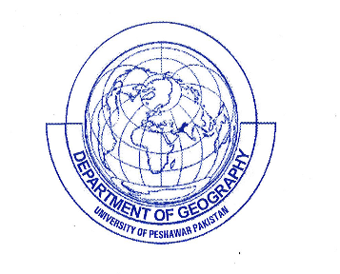
DEPARTMENT OF GEOGRAPHY
UNIVERSITY OF PESHAWAR, PAKISTAN
ADMISSION FORM
One Year Postgraduate Diploma in Geomatics (GIS/RS)
SESSION 2020-2021

1. STUDENT’S IDENTIFICATION

1) Name:
Male | Female

 |  | - |  |  | -

2) Gender Date of Birth

3) Father’s Name:

4) Uni: Registration No.
(if registered)

5) Address:

 |  |  |  |  | - |  |  |  |  |  |  |  | -

6) CNIC No. 7) Phone No.

8) Domicile with District: 9) Cell No.
2. ACADEMIC RECORD:
Examination Qualified | Year of passing | Marks obtained CGPA | Div/ Grade | Board/University | Subject/ Group / Field
BA/BSc or Equivalent
MA/MSc
MBA/MPA
Any other

3. DOCUMENTS TO BE ATTACHED:
i) DMC of qualifying examinations ii) one Passport size photograph
iii) Domicile Certificate iv) NOC/Study Leave approval (for govt. Employees)
v) Service Certificate vi) Migration certificate in case the applicant has passed
(in case of Govt. Servant) the last exam. from the University other than Peshawar University

DECLARATION
I hereby affirm that the given information in this application is true and correct to the best of my knowledge.
I will abide by all the rules and regulation of the University

Admission Fee Deposited:
Rs.__________ Receipt No._________ Dated:_______ Bank __________________

_________________
Applicant Signature
Dealing Assistant Chairperson / Coordinator

